**Map**

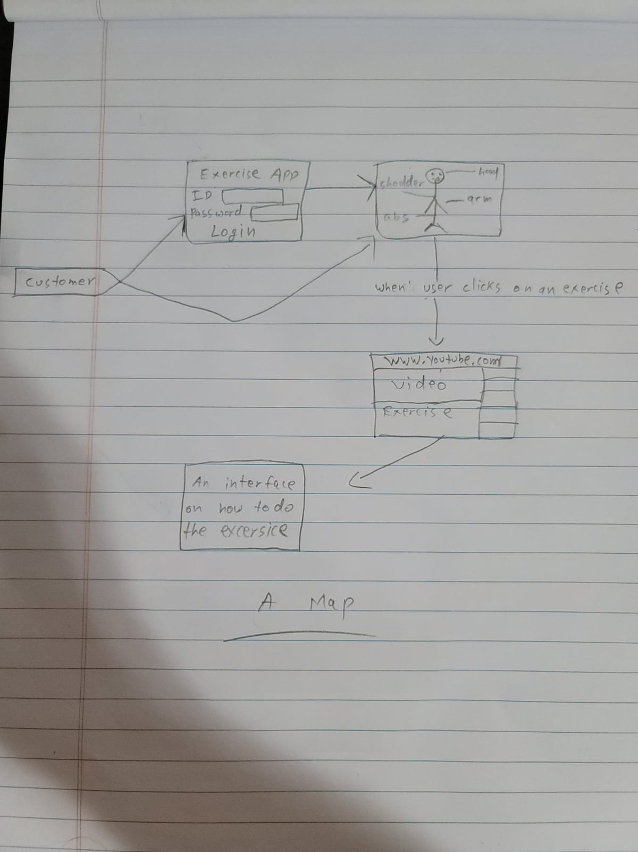

**Scenario**

A 20-year adult who wants to lose some weight and wants a fit body decides to download the exercise app. Upon downloading the app, the user is prompted to either create an account or login with an existing account. The user also has an option to continue as a guest. The adult is a beginner so he will have a beginner section to start his workout journey and it will available on an android or an ISO device.

User Stories

**User Story #1**



As a fitness trainer, I want to be able to train my client according to their requirements. I have clients ranging from 20-year-olds to 70-year-olds and I am looking for a fitness app that will have exercises from all age groups. It would be great if the app has a user and an instructor/trainer interface.

**User Story #2**



As an overweight individual, I want to be able to lose weight and want to track my daily/weekly progress. I would like an app that would guide me through exercises step by step and let me keep track of my weight daily/weekly. It would be great if I can connect to any nearby fitness trainer within the app.

**Feature List**

* Login page
* A human body with all the body parts
* Click on exercise and it will take you to a youtube video
* An instructor interface
* A gif of all the exercises
* A weight tracking feature
* Connect to a fitness trainer within the app